**Outline Use-Case: Survey Management**

***by Matthew Campbell***

# **Brief Description**

In this use case, the super admin can maintain, create, and delete surveys. In order to maintain a survey, a super admin can add, modify, or delete questions and domains.

## **Use Case Diagram**

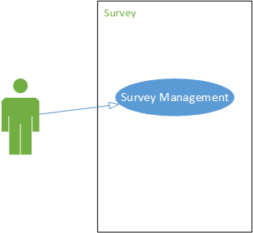

# **Basic Flow of Events**

2.1 The super admin goes to the survey page using the dashboard.

2.2 System Displays Buttons for Adding A Survey, and Back.

2.3. System displays the title of each survey, a button to view/edit the survey, a button to delete the survey, and a button to open or close the survey.

2.4 The super admin clicks view/edit survey on a survey that he/she wants to see.

2.5 System Displays Form for Information Regarding the Title of The Survey (A button that says modify title and a textbox).

2.6 System Displays Buttons for Adding A Question, Adding Multiple Questions, and Back, Domain.

2.7 System displays information for the domain of the questions, the questions themselves, and a couple of buttons that allow the super admin to edit or delete the question.

2.8 Admin takes a view of the questions.

2.9 Use case ends.

# **Alternative Flows**

## **<Edit Question>**

### *< Basic Flow>*

### *There is Invalid Input*

### *The superadmin exits the page because he/she does not edit a question.*

## **<Adding a New Question>**

### *< Basic Flow>*

## **Adding Multiple Questions**

### *< Basic Flow>*

### *< There is Invalid Input>*

## **Viewing Domain**

## **Editing Domain**

### *< Basic Flow>*

### *< The superadmin exits the page because he/she does not edit a domain.>*

### *< There is Invalid Input>*

## **<Adding a Domain>**

### *< Basic Flow>*

### *The superadmin exits the page because he/she does not edit a domAIN.*

### *Adding a new domain along with a new question*

## **Deleting Question**

## **Deleting Domain**

### *< Basic Flow>*

### *There are questions associated with the domain.*

## **Adding A Survey**

## **Deleting A Survey**

### *< Basic Flow>*

## **Modifying Title**

### *< Basic Flow>*

### *There is invalid input*

## **Opening a Survey**

### *< Basic Flow>*

### *<Wrong Survey Clicked>*

## **Viewing a List of Survey**

# **Key Scenarios**

Notes: Editing a survey consists of Scenarios 4.1.1 - 4.1.4

4.1 Success Scenarios:

4.1.1 Superadmin submits a question (Alternative Flows 3.1.1, 3.2.1, and 3.3.1)

4.1.2 Superadmin deletes a question (Alternative Flow 3.7)

4.1.3 Superadmin submits a domain (Alternative Flows 3.5.1, 3.6.1, 3.6.3)

4.1.4 Superadmin deletes a domain (Alternative Flow 3.8.1)

4.1.5 Superadmin creates a survey (Alternative Flow 3.5)

4.1.6 Superadmin opens a survey (Alternative Flow 3.12.1)

4.2 Failure Scenarios:

25.2.1 Superadmin submits invalid input (Alternative Flows 3.1.2, 3.3.2, 3.5.3, 3.11.2)